Product Sheet

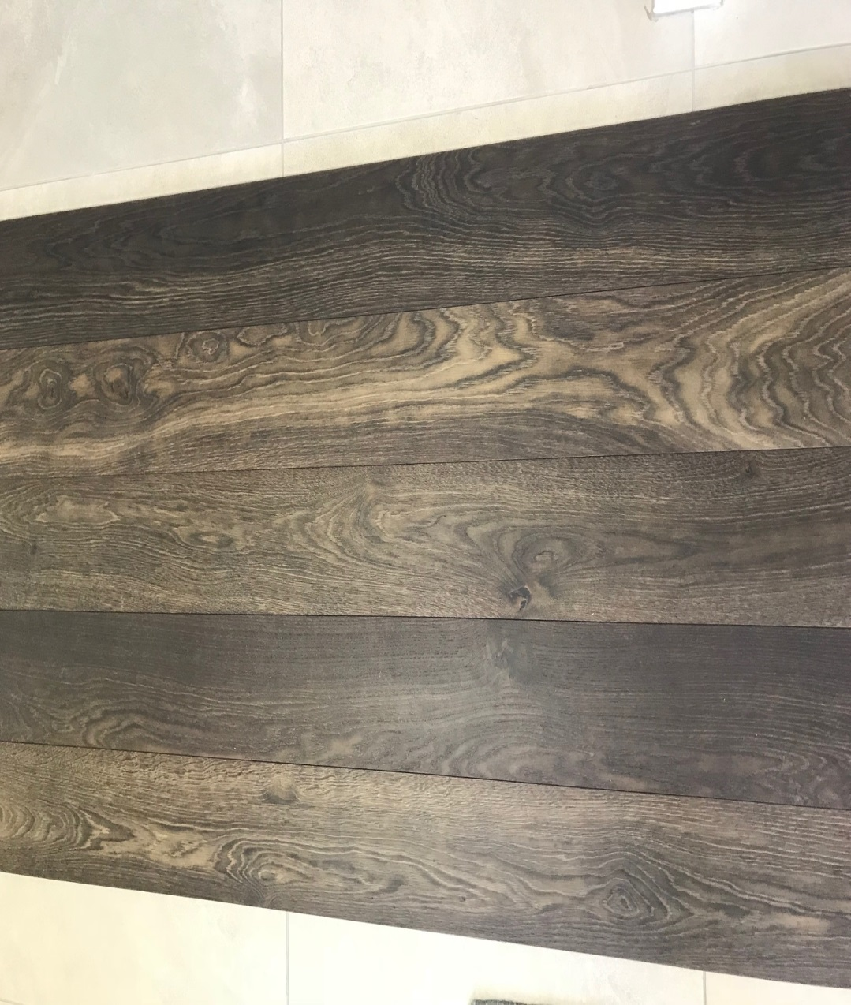

Range: Doghe Toscane
Name: Roma
Size: 15(4) x190x2000mm
Finish: Brushed / Matt
Treatment: Pre treated with 6 coats of water-based wax and UV oil.

Features:
The multiple layers of varnish, and subsequent UV lamp treatment after each layer creates a very durable treatment with a very high abrasion resistance. As a result no further treatment, oiling or sanding is required for the life of the product. Scratches do not affect the quality of the treatment and will only stretch the finish but not break the seal. However deep scratches or heavy sharp objects that damage the timber, we suggest replacing the particular piece.

Maintenance:
We suggest regular cleaning with a slightly damp cloth and neutral detergent, non-foaming, non-aggressive cleaners.

No need to re-sand the timber again for the life of it, unless you want to change the colour.

